**MARKET SEGMENT ANALYSIS**

**ELECTRIC VEHICLE MARKET**

**-Nivetha**

**Introduction:**

The electric vehicle (EV) market has experienced rapid growth in recent years, driven by advancements in technology, increasing environmental concerns, and supportive government policies. EVs, which include both battery electric vehicles (BEVs) and plug-in hybrid electric vehicles (PHEVs), are reshaping the global automotive industry and paving the way for a sustainable future.

**Global Market Size and Growth:**

The global EV market was valued at over $200 billion in 2023 and is projected to grow at a compound annual growth rate (CAGR) of more than 20% through 2030.Key growth regions include North America, Europe, and Asia-Pacific, with China leading in EV production and sales. Increasing consumer awareness of environmental issues and lower operating costs of EVs are driving adoption. Government incentives, including tax credits, subsidies, and exemptions from tolls, have played a critical role in accelerating EV purchases.

Improvements in battery technology, such as higher energy densities and reduced costs, are making EVs more affordable and practical. The development of faster charging infrastructure is addressing consumer concerns about range anxiety. Many countries have announced plans to phase out internal combustion engine (ICE) vehicles, with ambitious targets for 100% EV adoption by 2035 or earlier. Emission regulations and carbon-neutrality goals are pushing automakers to invest heavily in EV production.

**Segment Analysis**

The EV market can be segmented based on vehicle type, powertrain, and end-user. Here is an overview of each segment:

Passenger Vehicles Comprise the largest segment of the EV market, driven by high consumer demand and government incentives. Examples include Tesla Model 3, Nissan Leaf, and BYD Tang.

Commercial Vehicles Adoption of electric buses and delivery vans is increasing, particularly in urban areas to meet emission reduction targets. Companies like Rivian and Arrival are investing heavily in this segment.

Two- and Three-Wheelers Popular in Asia-Pacific, these vehicles offer an affordable and efficient solution for short-distance travel.

Battery Electric Vehicles (BEVs) Fully electric vehicles powered by rechargeable batteries, accounting for the majority of EV sales. Plug-in Hybrid Electric Vehicles (PHEVs) Combine internal combustion engines with batteries, offering extended range and flexibility. Fuel Cell Electric Vehicles (FCEVs) Use hydrogen fuel cells for energy, a growing segment but currently limited by infrastructure.

Individual Consumers Dominate the passenger vehicle market, driven by environmental awareness and lower total cost of ownership. Fleet Operators Ride-hailing companies and logistics firms are increasingly transitioning to EV fleets to reduce operational costs and comply with regulations.

Public Sector Governments are adopting electric buses and municipal vehicles to lead by example and achieve sustainability goals. Challenges in the EV Market Infrastructure Gaps Despite advancements, the lack of widespread charging infrastructure remains a significant barrier in many regions.

Battery Supply Chain Dependence on raw materials like lithium, cobalt, and nickel has created supply chain vulnerabilities and raised ethical concerns about mining practices. High Initial Costs Although EV prices are declining, the upfront cost remains higher than traditional ICE vehicles, limiting accessibility for some consumers.

Grid Readiness Increased EV adoption places additional demand on power grids, requiring upgrades to ensure reliable energy distribution.

**Key Players in the Market Automakers:**

Tesla, BYD, Nissan, General Motors, and Volkswagen are among the leaders in the EV market. Traditional automakers are transitioning their portfolios to include more EVs.

Battery Manufacturers Companies like CATL, LG Chem, Panasonic, and Samsung SDI dominate the EV battery production market. Charging Infrastructure Providers ChargePoint, EV-go, and Ionity are expanding charging networks to meet the growing demand.

**MARKET SEGMENTATION:**

Market segmentation in the electric vehicle (EV) market enables manufacturers and marketers to identify and address the unique needs of different consumer groups, facilitating targeted strategies and efficient resource allocation. Demographically, several factors influence EV adoption. Income level remains a key determinant, with higher-income consumers gravitating toward premium EV brands such as Tesla, Lucid Motors, and Rivian, known for their luxurious features and cutting-edge technology. On the other hand, middle-income households often opt for more budget-friendly models like Hyundai Ioniq, Chevrolet Bolt, or the Nissan Leaf, which offer a balance between affordability and performance.

**Geographic Segmentation**

Geographical- EV adoption varies based on infrastructure development and regional policies. Urban areas with robust charging networks and government-supported incentives witness higher EV penetration compared to rural regions, where limited access to charging stations can hinder adoption. Countries with strict emission regulations and financial benefits, such as subsidies and tax rebates for EV buyers, lead the market, with regions like Europe, China, and parts of North America driving global growth. Climate also plays a critical role, as colder regions often experience reduced battery efficiency, which can deter potential buyers unless cold-weather battery solutions are provided.

**Psychographic Segmentation:**

Psychographic factors highlight the importance of consumer values, lifestyles, and attitudes toward sustainability. Eco-conscious individuals who are motivated by environmental responsibility are naturally inclined toward EVs, viewing them as a way to reduce their carbon footprint. Tech enthusiasts are another crucial segment, drawn to innovative features like autonomous driving capabilities, AI-assisted driving aids, and over-the-air updates. These consumers value the advanced technological ecosystem EVs often offer, including smart charging apps and integration with home energy systems.

**Behavioural Segmentation:**

Behavioural segmentation sheds light on consumer habits, such as usage patterns, loyalty, and purchase motivations. Long-distance drivers and road-trip enthusiasts prioritize vehicles with extended range and access to a fast-charging network, while urban dwellers seek compact, cost-efficient models suited to city driving. Additionally, early adopters and brand-loyal customers form a crucial segment, often influencing broader consumer trends and promoting trust in new EV technologies. Motivations for purchasing EVs vary, from saving on fuel costs and accessing government incentives to achieving social recognition and fulfilling personal commitments to sustainability**.**

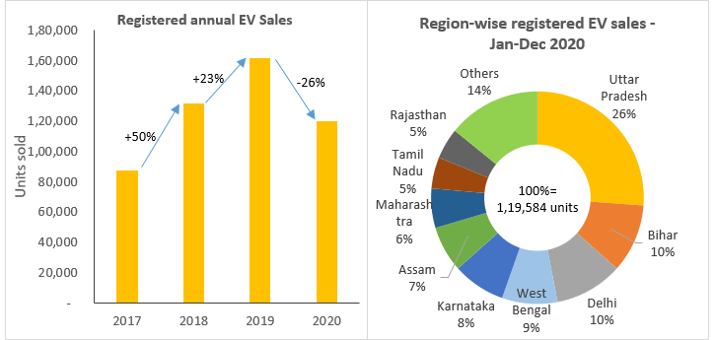

**Price-based segmentation:**

Price-based segmentation is another critical factor in understanding the EV market. Consumers range from luxury buyers, who invest in high-end brands like Porsche Taycan or Tesla Model S, to cost-conscious individuals seeking affordable electric cars for everyday use. Fleet operators represent a separate segment, focusing on total cost of ownership, efficiency, and reliability. Companies in ride-hailing, logistics, and public transportation sectors are increasingly adopting EVs to reduce operational costs and meet sustainability goals.

**Deep Learning:**

Deep learning is a subset of machine learning that uses neural networks to automatically learn patterns from large datasets. It is widely used for tasks like image recognition, NLP, and speech processing. For example, in an image classification task, the model might use a Convolutional Neural Network (CNN) with layers like convolutional, pooling, and fully connected layers to predict labels based on input images. During training, loss functions like cross-entropy and optimization methods such as Adam are used. Results are evaluated using metrics like accuracy and confusion matrices.

For example, in an image classification task, a model might use a Convolutional Neural Network (CNN) with layers like convolutional, pooling, and fully connected layers to predict labels based on input images. The model could be trained to classify animals, distinguishing between categories like cats and dogs. During training, a loss function such as cross-entropy would be used, and an optimizer like Adam would adjust weights to minimize this loss.

To evaluate the model’s performance, metrics like accuracy and confusion matrices would be used. For instance, after testing the model, we could measure how accurately it classifies a cat as "cat" and a dog as "dog" in a set of images, and the confusion matrix would show how often it misclassifies one animal for another. This helps identify areas of improvement, such as addressing specific misclassifications or increasing the dataset size.

**Problem Statement:**

The electric vehicle (EV) market is currently limited by several factors that hinder its widespread adoption. These challenges include the high initial purchase cost, inadequate charging infrastructure, and concerns about battery life and range. As a result, many consumers are hesitant to switch from traditional gasoline-powered vehicles, slowing down the transition to cleaner, more sustainable transportation options. Addressing these barriers is crucial for accelerating the adoption of EVs and achieving environmental sustainability goals.

**Data Collection:**

Data collected from various online sources, including platforms like **Kaggle**, **data.gov.in**, and Google Dataset Search which offer a wide range of datasets across different domains.

<https://www.kaggle.com/datasets>

<https://www.data.gov.in/>

<https://datasetsearch.research.google.com/>



**Data Pre-Processing**

Preprocessing involves preparing raw data for analysis by cleaning and transforming it into a format suitable for modelling. This step includes handling missing values, correcting errors, removing duplicates, and standardizing or normalizing data to ensure consistency. Additionally, categorical variables might be encoded, and features may be scaled to improve model performance. The goal of preprocessing is to ensure the data is accurate, complete, and ready for analysis, enhancing the quality of insights drawn from the model.







**Data Visualization:**

Data visualization is the process of representing data in graphical or visual formats such as charts, graphs, and plots. It helps to uncover patterns, trends, and relationships within the data, making it easier to understand and interpret. Common tools for data visualization include bar charts, line graphs, histograms, scatter plots, and heatmaps. By using visualizations, complex datasets can be presented in an intuitive and engaging way, aiding decision-making, identifying anomalies, and communicating insights effectively to stakeholders.

I focused on key factors such as top speed and range of electric vehicles. I performed a correlation analysis to examine how these factors relate to each other and other variables in the dataset. To visually represent these relationships, I used a heatmap to display the correlation matrix, allowing for easy identification of strong or weak correlations between variables.



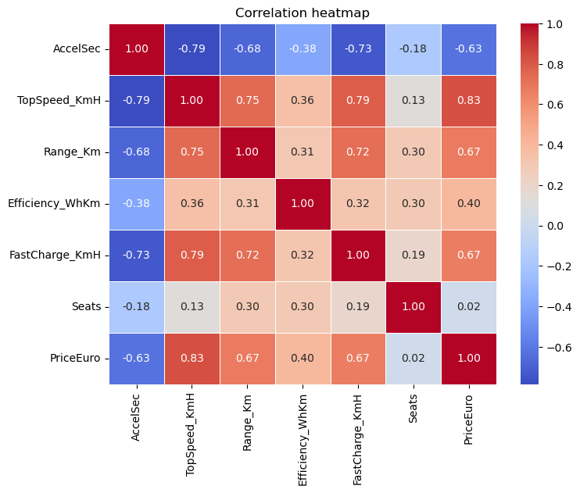

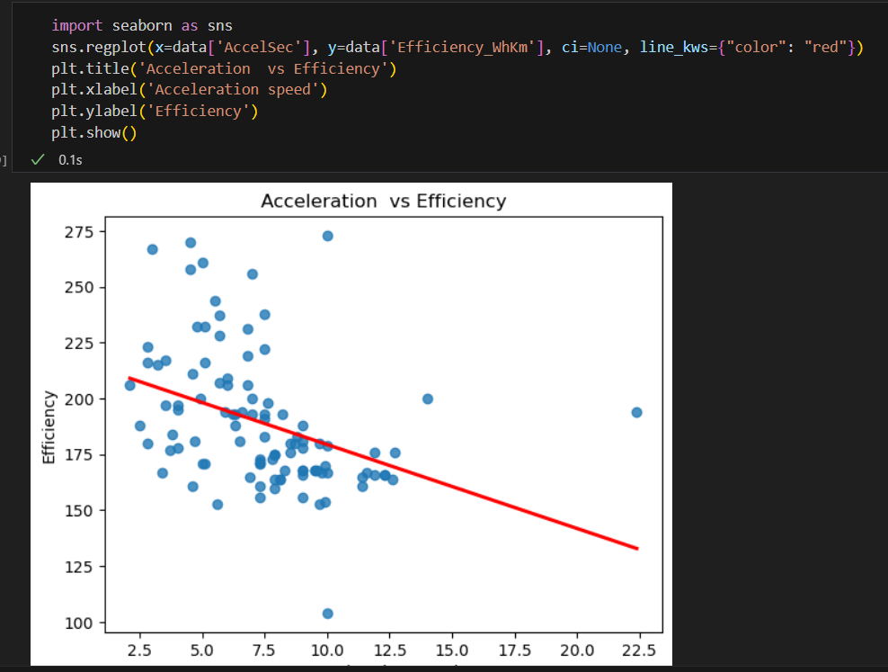

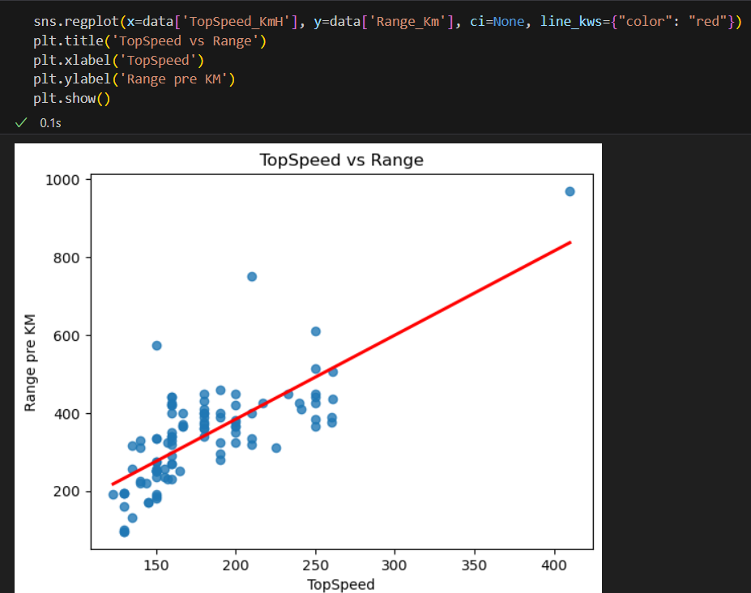

**Feature Scaling And Train_Test:**

Feature scaling is a technique used to standardize or normalize the range of independent variables (features) in a dataset. It ensures that no single feature dominates others due to differences in scale. Common methods include min-max scaling, which resizes the data to a fixed range (usually 0 to 1), and standardization, which transforms data to have a mean of 0 and a standard deviation of 1. Feature scaling is particularly important for algorithms that rely on distance calculations, like k-nearest neighbours or gradient descent-based models, as it helps improve model performance and convergence**.**



**Model Processing:**

In this project, a deep learning model was built and trained using the dataset, where the model learned patterns and relationships from the data. The training process included selecting an appropriate architecture, configuring hyperparameters, and optimizing the model using techniques like backpropagation. Once trained, the model was evaluated on its performance using metrics such as accuracy or loss, ensuring it could generalize well to new, unseen data.



**Model Prediction:**

Model prediction involves using the trained deep learning model to make forecasts or classifications based on new, unseen data. After the model has been trained and validated, it is applied to predict outcomes for test data or real-world input. The predictions are compared to actual values to evaluate the model's performance, and adjustments can be made to improve accuracy

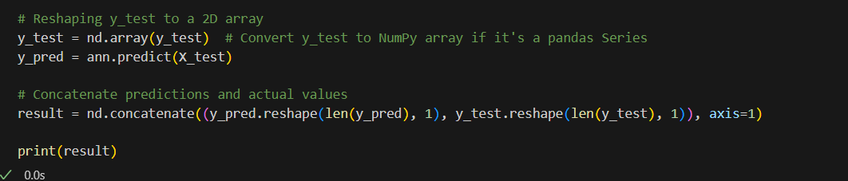

**Model Evaluation:**

Model evaluation is the process of assessing the performance of a trained model using various metrics and techniques. It involves comparing the model's predictions against actual outcomes to measure its accuracy, precision, recall, or other relevant metrics. Common evaluation methods include using test datasets, cross-validation, and confusion matrices. This step helps identify how well the model generalizes to new data and whether it meets the desired performance criteria. Based on the evaluation results, the model can be refined or tuned to improve its accuracy and robustness.



**Conclusion:**

Deep learning model built for this project effectively learned patterns from the dataset and provided valuable predictions. Through preprocessing, feature scaling, and model training, we were able to optimize the model to handle key factors like top speed and range of electric vehicles. The model was evaluated using various metrics, ensuring it performed well on unseen data. While the model showed promising results, there may still be room for improvement through further tuning or exploring alternative architectures. Overall, the model demonstrates potential for making accurate predictions and providing insights into electric vehicle performance.

GITHUB LINK :